**National Innovation Center**



**Proposal on:**

**IOT Based Wireless Notice & information display Board**

**SUBMITTED BY:**

Biplov paneru

Ram Kishor Yadav

Rohit bahadur chand

**SUBMITTED TO:**

**National Innovation Center**

# ACKNOWLEDGEMENT

Firstly, we would like to express our deep sense of respect and gratitude towards Dr. Mahabir Pun sir for encouraging us to take forward this project in National Inovation Center, Nepal. We aim to develop a board that can flow information to people easily using a mobile app and a doisplay board wirelessly.

# ABSTRACT

Information dissemination using digital notice board plays an imperative role in this digital world. This work is primarily aimed at developing a wireless information board for displaying and broadcasting the announcements and notices that the user sends from the Internet using the IOT technology. By providing a sufficient power supply, the Raspberry Pi, node MCU and LED display work properly and the display is controlled by the android application. The application can be used by connecting it to the internet and this enables the admin to send the information from wherever in the planet and could be visualized in a matter of seconds. The admin uses the app by setting the correct username and password for WIFI. For sending information, PC or mobile phone are utilised and at recipient end, raspberry Pi is connected to the Web.

The admin can send the data in the form of text or voice, which in turn would be displayed on the distant noticeboard. The LED display is to display the text/voice that the user has sent and the speaker is to announce the received text message. The displaying text would be scrolling in the display. By using the text to speech software, announcement the text that is scrolling on the LED screen become possible. Earlier the Wi-Fi notification board had been used and thereby experiencing a limit on coverage. In this proposed method, the Internet is used as a means of communication and no coverage problem exists.

This technical paper deals about development of IoT based electronics notice board using available IP based infrastructure & IoT devices. Smart notice board can be developed to make noticing system much simple and faster & cost effective interface with web & application the system is platform independent which overcomes the disadvantages of existing Noticing system. Wireless interface of system gives access to both IP based as well as cellular based network devices to provide input to the system. This prototype developed can be used to eliminate the need of huge bill boards.

**Keyword: -** Arduino,Notice Board, WIFI, Smart phone, Security ,Blynk App

# Table Of Contact

Contents

ACKNOWLEDGEMENT ii

ABSTRACT iii

Table Of Contact iv

1 INTRODUCTION 1

1.1 Background 1

1.2 Objectives and scope 1

1.3 Applications 1

1.4 Overview of Proposal 1

2 LITERATURE REVIEW 2

3 METHODOLOGY 3

3.1 Basic Block Diagram 3

3.2 Circuit Diagram 4

4 Hardware And Software 4

4.1 ESP8266 4

4.2 Arduino Nano **Error! Bookmark not defined.**

4.3 LED Display **Error! Bookmark not defined.**

5 Cost Structure 6

6 Economical Benefit 7

7 Conclusion 8

8 References **Error! Bookmark not defined.**

# INTRODUCTION

## Background

Notice Board is the most common and primary apparatus in any institution, organization, or public utility places like a bus station, railways stations, and parks. The problem of this display is to carry a computer or for generating and sending message to LED moving display board is big problem and it can also increase the cost.

This project deals with a wireless notice board. The main objective of the project is to develop a wireless notice board that displays messages sent from the webserver/mymqtt apps. When a user sends a message, it is received by a Wi-Fi Module through Local Web Server.

## Objectives and scope

The main objective of the project using Wi-Fi module we can send message to any distant location and to develop a wireless notice board that display notice in the form of text. Consume less power and easy to operate also notification can be delivered in within second. The voice calling feature can be added with the proposed system as a further enhancement for using the system.

## Applications

* It has remote application achieved by any smart phone or PC.
* This project reduces Human work for maintaining the Notice Board.
* It also saves printing as well as paper costs.
* Due to to the use of Wi-Fi system which is the fastest usage of internet, it will give high performance and it will be cost effective.

## Overview of Proposal

A display connected to a server system should continuously Seen for the incoming messages from the user, process it, and display it on the LED screen. The message displayed should be updated every time the user sends new information. Only authenticated people should update the data to be displayed on the LED.

# LITERATURE REVIEW

Notice In the year 2018, few researchers along with Dr. Surendiran worked with GSM-based display and has developed an IoT-based Message Scrolling LED Display. The proposed system is to design displaying message using Arduino Uno and IoT. Mobile SIM is used for transferring the message from the user to microcontroller, Neeraj Khera, Divya Shukla, has developed a wireless advisory board based on Automaton (Android). The targeted model aims to show a message in the display using an Arduino Uno microcontroller. The mode of transferring data in this is through either Bluetooth . In this proposed system the data can passed only when the user connected to the Bluetooth of the microcontroller. So, the data can only pass when the user is nearby the setup.

Normally when we go to the public places like school,hospital,buspurk,park,offices,etc, we can see notice is noticed on board of wood with printed paper .However somewhere we can see digital notice board are used like ,near the thapathali campus but there was no wireless system used.

This paper deals with wireless based notice board incorporating the widely used Wi-Fi Module to facilitate the communication of displaying message on notice board via user's mobile phone. Its operation is based on microcontroller ESP8266programmed in assembly language.

In this paper simha, it can be easily integrated with general purpose display board to provide its mobility. The system acept the message from the use of mobile phone app(blynk) and display on the board.

# METHODOLOGY

Proposed System This paper proposes an IoT based wireless notice board. The operation of this system is to display and announce the text message received in the ESP8266 which is sent by the user from the mobile application and the message is passed to the display though node MCU. The android application mymqtt app. A web link is created to establish the connection between the Android Application and LED display. The GPIO pins are used for the connection between the LED display, ESP8266 and node MCU. The proposed system con1sists of ESP8266, node MCU, LED display.

## Basic BlockDiagram

Power Supply

ESP8266

Led Display

Mymqtt

Fig:Block Diagram

## Circuit Diagram

To make IoT Based Web Controlled Smart Notice Board, we need to interface LED Display with Nodemcu ESP8266 Board. So the circuit diagram with detailed connection is given below.

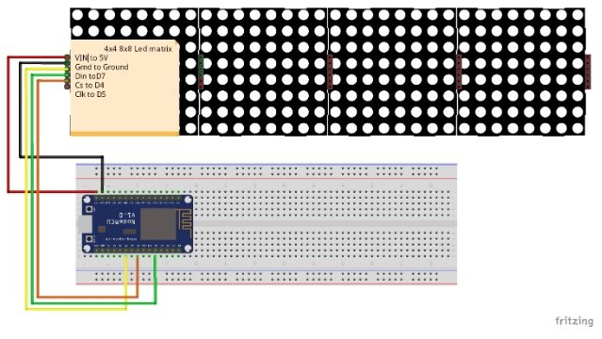

Fig: Circuit diagram

Source:https://maker.pro/storage/EbUid9Q/thumb/EbUid9QCQZh3zHhzVNQpZ1HxkdxjlOpnQw83VP4g.jpeg

This project uses an LED dot matrix based on the MAX7219 from Maxim, which is an 8-bit LED display driver chip. These chips are designed to control up to 8-digit 7-segment digital LED displays, bar graph displays, or 8x8 LED dot matrix displays. Arduino IDE provides a library called Matrix with sample code written for the MAX7219 chip.

# Hardware And Software

## ESP8266

The ESP8266 is a low-cost [Wi-Fi](https://en.wikipedia.org/wiki/Wi-Fi) microchip, with built-in [TCP/IP networking software](https://en.wikipedia.org/wiki/TCP/IP_stack), and [microcontroller](https://en.wikipedia.org/wiki/Microcontroller) capability, produced by [Espressif Systems](https://en.wikipedia.org/w/index.php?title=Espressif_Systems&action=edit&redlink=1) in Shanghai, China.

The ESP8285 is a similar chip with a built-in 1 MB flash memory, allowing the design of single-chip devices capable of connecting via Wi-Fi.

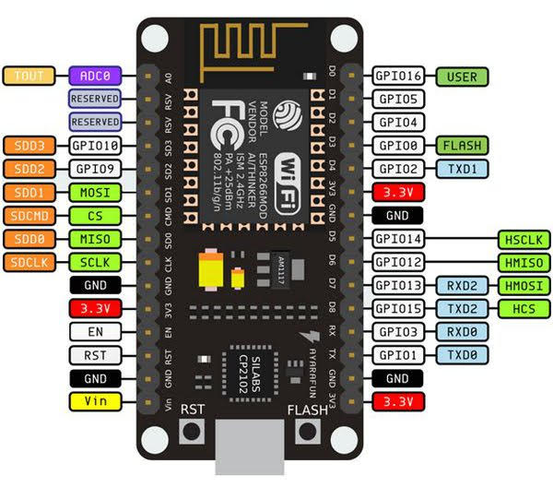

Fig: ESP8266

**4.2LED Dot Matrix Display (32x32)**

Matrix LED 16x16 is an array of LEDs that you can display numbers, letters, and shapes on it. Dot matrixes are indicated by the number of rows and columns. The most popular type of Dot Matrix is its 32×32 type, which provides 32x32 LEDs in 32 rows and 32 columns. To control the Dot Matrix 32x32 simply, you should connect each row and each column to a digital pin, which means you need 16 digital pins! So, it’s not a proper way.

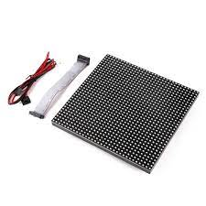

To control Dot Matrix, there are modules based on MAX72xx ICS which need to connect to 4 digital pins instead of 16. You can also connect multiple Dot Matrix (up to 8) to each other without needing any extra pin and cascades them.

**Source**: https://create.arduino.cc/projecthub/electropeak/using-8x8-dot-matrix-led-with-arduino-cascade-connection-5cecff

**4.3 Arduino IDE**

Embedded C is one of the most popular and most commonly used Programming Languages in the development of Embedded Systems. There are many popular programming languages like Assembly, BASIC, C++ etc. that are often used for developing Embedded Systems, but Embedded C remains popular due to its efficiency, less development time and portability. An Embedded System can be best described as a system which has both the hardware and software and is designed to do a specific task. A good example for an Embedded System, which many households have, is a Washing Machine.

Arduino IDE works on C and C++ programming language. The Arduino Integrated Development Environment - or Arduino Software (IDE) - contains a text editor for writing code, a message area, a text console, a toolbar with buttons for common functions and a series of menus. It connects to the Arduino and Genuine hardware to upload programs and communicate with them. Programs written using Arduino Software (IDE) are called sketches. These sketches are written in the text editor and are saved with the file extension. Ion. The editor has features for cutting/pasting and for searching/replacing text. The message area gives feedback while saving and exporting and also displays errors. The console displays text output by the Arduino Software (IDE), including complete error messages and other information.

Cost Structure

|  |  |  |  |  |
| --- | --- | --- | --- | --- |
| S.N | Hardware | Quantity | Rate | Amount |
| 1 | ESP8266 | 1 | RS.650 | RS.650 |
| 2 | LED Display | 1 | RS.8000 | RS.8000 |
|  | | | | |
| 4 | Jumper Wire(40pcs/pkt) | 1 | RS.500 | RS.500 |
| 5 | Male & Female Header (40 pin) | 2 | RS.100*2 | RS.200 |
| 7 | Adapter | 1 | RS.250 | RS.250 |

|  |  |
| --- | --- |
| Total | RS.10000 |

# Economical Benefit

* It has remote application achieved by any smart phone or tablets/PC
* This Project reduce Human work maintaining the Notice Board.
* It also saves the printing as well as paper costs.
* Because of Wi-fi access password will only be known to the Head person.
* Due to the use of Wi-fi system which is the fastest usage of internet ,it will give high performance and it will be cost effective.

# Conclusion

In this digitized world, it is vital to implement most modern digital notice boards which outweigh the traditional paper-based notice boards. The key concept of this proposed work is to develop a display board wirelessly that exhibitions the information sent from the mobile application used by the user. Thus, the project gives the easiest approach of sending and displaying information in necessary places like schools and colleges. By using the text to speech software, announcement the text that is scrolling on the LED screen become possible. Earlier the Wi-fi notification board had been used and thereby experienced a limit on coverage. In this proposed method, the Internet is used as a means of communication and no coverage area problem exists.

# References

[1] Nami Susan Kurian. (2021). IoT based Wireless Notice Board using ESP*.* Delhi: nternational Conference on Recent Trends in Computing (ICRTCE-2021).

[2] Wikipediya. (2019, jan 15). Chrome. Retrieved from Wikipedia: https://en.wikipedia.org/wiki/Arduino_Nano

[3] Tech vegan. (2020, aug 4). youtube. Retrieved from youtube: https://www.youtube.com/watch?v=hMW9nz48thg

[4] Admin. (2020, may 10). Chrome. Retrieved may 10, 2020, from how2electronics: https://how2electronics.com/iot-web-controlled-notice-board-esp8266/?fbclid=IwAR3ayZqEl30fphxp4J8SuwJRlVgicZ7YYUd3VReqH2Z0HJIjdXM-L0G2mMM

[5] HOw2electronics. (2020, aug 10). Chrome. Retrieved from howtwoelectronics: https://how2electronics.com/wp-content/uploads/Web-Controlled-Smart-Notice-Board-Circuit.jpg

[6] Cedric. (2019, march 15). Chrome. Retrieved from Cedric-jung-eu: https://cedric-jung.eu/assets/images/nodemcu.jpg

[7] Pranesh. (2022, feb 15). chrome. Retrieved from opencircuit: https://cdn.bodanius.com/media/1/73b102980_Arduino-Nano-R3_x.png

[8] Hridendra. (2017, dec 23). chrome. Retrieved from sunrom: https://www.sunrom.com/img/p/657/657_800.jpg